Harvest time!

Jack & Charlye Price
• • •
Field Address: 625 Kaonga Extension P.O. Box 670424 Mazabuka, Zambia, Africa
Email: jcinzambia@yahoo.com
Website:
www.zambiaunshackled.com
Facebook: JackCharlye Price
Sermon Audio: An Established End Missions
Sending Church: Marion Baptist Church 312 West Wetz Street Marion, TX 78124 Pastor Rudy Elizondo 1-830-420-7084
Send Support to: Central Missionary Clearinghouse P.O. Box 219228 Houston, TX 77218-9228
A Sweet Savor from Mazabuka
Zambia Unshackled Ministries | 7/1/2017 | Romans 1:11

  - It’s burning!
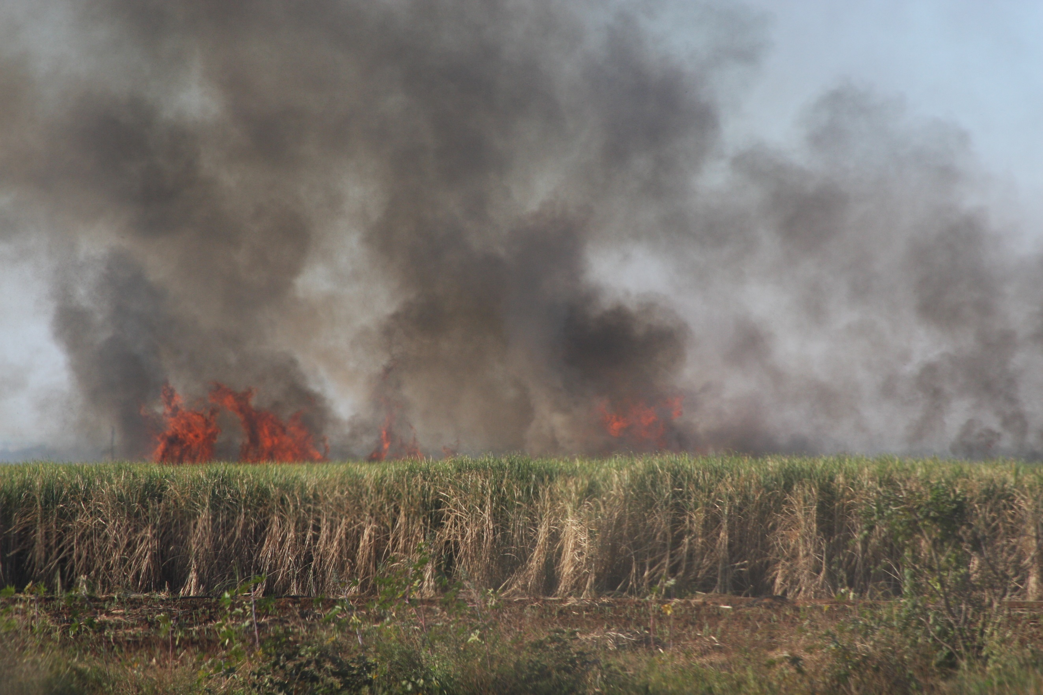

Miles and miles of sugar cane, and it’s on fire! Did you know that’s how your sugar begins its trip to your table? Before it can be harvested the fields are set on fire. The large leaves of the cane must be removed before the cane is cut in order to preserve the amount of sugar inside the cane. Removing the leaves also prevents workers from being cut, and the fire runs all of the snakes out of the area. So, for the most part, remove the unwanted leaves to obtain a better sugar yield. Reminds you of the Lord pruning and gleaning, yes?

New Ministry
  - New village ministry in Chizoma

While all of our town ministries continue to flourish, we have now started a new village ministry on the farm that was given to us in Chizoma. A very special thank you to Chief Mwanachingwala and to Headman Mumba for their assistance in establishing a church for this area. We will be meeting each Tuesday afternoon at the home of Headman Mumba for Bible study for men, ladies, and children. We had our first meeting this past week, and had 5 professions of faith among the women. This Sunday (7/9/17) will be our first Sunday service on the farm. We are so praying for an outpouring of the Holy Spirit on this place! We have even been given a temporary house for Pastor Siachibaba until we can build the church and his home on the farm. God’s blessings have been so abundant! We are working feverishly to get everything in place before rainy season starts in November, and we are actually taking a furlough this year (Charlye has missed 4 Christmases at home). We are planning at present to fly back to the States in mid- September, so everything has to be up, running, and settled by then.
We want to send out a special thank you to Rachael Mangum. Rachael is one of our prayer warriors, and even keeps a schedule of where we are and when so she can be praying for us at that time. (We are six hours ahead of EST until you revert to DST in November, then it will be 7 hours) That is how we know someone is holding the ropes at home. Could you do that for us at some point? Our schedule is as follows: Sunday morning services in Kabobola and Chizoma. Sunday afternoon services in Kaleya. Monday morning Bible study at the Men’s prison. Pastor Muyeyi had over 250 men this past week, and he was unable to count the number of hands that went up for salvation! Tuesday afternoon Bible study for men, women, and children in Chizoma. 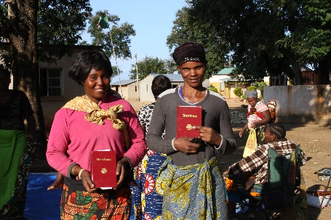 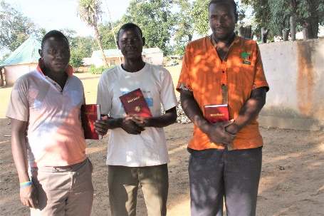 Wednesday morning training for the pastors at our house. Wednesday afternoon Bible study for all groups in Kaleya.
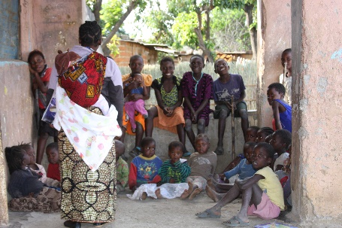 Thursday afternoon Bible study and Health teaching in Nakambala Boys Reformatory. While the boys were hesitant about this white woman (mzungu muchembeli) at first, they have now adopted Charlye as their white grandma.
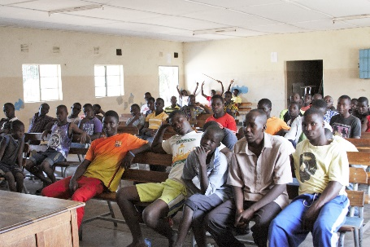 Friday afternoon Bible study for the women in Kabobola, with prayer time for the church following.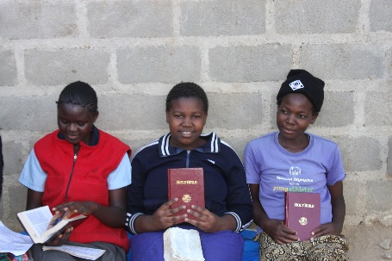 Those you see with Bibles just “earned” them by memorizing the Romans Road and being able to explain the meaning of the verses. Our thanks to BEAMS for the precious Word! When the ladies learn the books of the Bible in order, they are given a new chitenge (skirt) and the men are given a new shirt. Saturdays are full with outreach for children into 6 compounds here in Mazabuka, then Youth training at 2 p.m. Yes, we are tired, and yes, we need help!

Our prayer needs: 1) trained workers; 2) funds for the completion of a church building and house at Chizoma; 3) a new bush vehicle as we are running our little Frontera ragged; 4) healing for Jack as he fell and broke his shoulder 8 weeks ago, and it has been slow to heal.
Since we are coming home on furlough in September, please let us know if you would like to have us come to your church and present an update on the work here. We will fly into Texas in September, and will be in North Carolina for Christmas. We will return to Zambia the end of January or early February. You may contact us via email at jcinzambia@yahoo.com. Our deepest thanks to all of you for your steadfastness, both in prayers and in giving.
Breaking the chains of sin thru the Gospel of Jesus Christ!
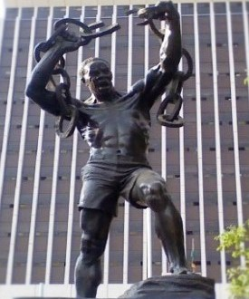

Joyous and grateful in Christ,
Jack & Charlye Price
Your Missionaries to Zambia

